Matrix Booking

Business Rules Workshop

V5 – July 2025

Contents

Things to consider 3

Buildings and Resources within the Organisation 3

Business Rules for Resource Types 4

Rooms 4

Desks 5

User Roles 6

Specific Configuration Options for Matrix Booking 7

Visitor Management 8

Logo requirements: 8

Instructions for Web application Logo & Floorplan/Sense Kiosk logo 9

Instructions for Email Logo 9

Help Text 10

**Getting Started with Matrix Booking: Key Considerations for a Smooth Implementation**

Matrix Booking is designed to be easy to implement and manage. However, to ensure a smooth, stress-free transition, there are a few important areas to consider during the setup process.

This document outlines the key elements you’ll need to review as part of your planning. While some areas may require further exploration or decisions, this guide serves as a helpful checklist to support your implementation journey. It also enables us to gather the information required to configure your system to meet your specific needs.

Please note that all configuration settings can be updated at any time, including after your system is live—ensuring continued flexibility as your requirements evolve.

We’re here to support you throughout the process and ensure your experience with Matrix Booking is seamless and successful.

# Things to consider

1. Business Rules should ideally be consistent across the organisation, the buildings, rooms, desks etc. (as this makes future support and maintenance easier and therefore communications to staff).
2. These are the rules we agree in advance to ‘ready’ the system for go live. Once handed over to your onsite administrators, these rules are yours to own and amend as and when you see fit.
3. It is important to correctly capture all the relevant information about your organisation. The system set up is based on the information you have given us in the completed templates. In each section we run through the various configuration settings (based on business rules) needed for each building / area and then also some more general configuration settings for the system as a whole.

**Please provide the NAME of your organisation the way you wish it to appear in Matrix Booking?**

# Buildings and Resources within the Organisation

**How many buildings are in scope for launch**

**Please provide the names of all buildings and the contact who will be providing the information**

|  |  |  |
| --- | --- | --- |
| Building Name | Contact Name | Contact Email address |
|  |  |  |
|  |  |  |
|  |  |  |

# Business Rules for Resource Types

## Rooms

|  |  |
| --- | --- |
| How far in advance do you want the user to be able to create the booking?  *“e.g. I want to prevent staff booking rooms more than 2 weeks in advance”* | XX days / weeks / months |
| Is cost code needed to book room as mandatory? | YES / NO |
| Does the room require people to ‘start’ the booking?  *(If yes, this means a ‘start’ button will appear in ‘My Bookings’, mobile and any room signage if applicable.)* | YES / NO |
| How far in advance can you start the booking? (e.g. If I arrive at the meeting 15 mins early, can I click ‘start’ to say I am there and stop my booking from auto cancelling?) | XX Minutes |
| If you require bookings to be started, do you wish to auto cancel the booking if it’s not started? | YES / NO |
| If auto cancel on, how long before cancelling? | XX Minutes |
| If it is part of a repeat booking, then after how many consecutive missed instances should we cancel the whole series? | X |
| We can send up to THREE reminders in advance (e.g. one week, three days, one day before the bookings), how many would you like and when would you like them sent? (The reminder will list your bookings in a single email, not one email per booking and all reminders will be sent at the **same time each day for all categories**.) | Reminder 1: XX days before the booking  Reminder 2: XX days before the booking  Reminder 3: XX days before the booking  xx:xx (default is 10am if not specified) |
| Room Signage devices – If using them, can people book directly from the device? | YES / NO |
| Should bookings be assigned to owners or booked anonymously? (‘Anonymous’ means the booking is made in the name of a generic signage user account, ‘assigned’ means you can select the host of the meeting from your Matrix Booking directory) | ASSIGNED / ANONYMOUS |
| Do you have photos or images of the rooms? If yes, who will provide these? (please ensure photos are named to match the rooms) | YES / NO |
| Do you want to allow ‘overlapping’ booking? (e.g. Can Janet Smith have TWO rooms booked at the same time?) Note that this applies to regular users, administrators and location managers can override this and book multiple resources for themselves and others. | YES / NO |
| Is a ‘Title’ mandatory for a booking? | YES / NO |
| Do you want ‘Find someone’ enabled for this category? | YES / NO |
| Do you want to set up Group prioritisation bookings for rooms (e.g. The Finance team are able to book 3 weeks in advance, the IT can book 2 weeks in advance and everybody else can book 3 days in advance) | YES / NO |

## Desks

|  |  |
| --- | --- |
| How far in advance do you want the user to be able to create the booking?  *“e.g. I want to prevent staff booking desks more than 2 weeks in advance”* | XX days / weeks / months |
| If the desk is booked, can it be booked again the same day? | YES / NO |
| Does the desk require people to ‘start’ the booking?  *(If yes, this means a ‘start’ button will appear in ‘My Bookings’ and on the mobile app.)* | YES / NO |
| How far in advance can you start the booking? (e.g. If I arrive 15 mins early, can I click ‘start’ to say I am there and stop my booking from auto cancelling?) | XX Minutes |
| If you require bookings to be started, do you wish to auto cancel the booking if it’s not started? | YES / NO |
| If auto cancel on, how long before cancelling? | XX Minutes |
| If it is part of a repeat booking, then after how many consecutive missed instances should we cancel the whole series? | X |
| We can send up to THREE reminders in advance (e.g. one week, three days, one day before the bookings), how many would you like and when would you like them sent? (The reminder will list your bookings in a single email, not one email per booking and all reminders will be sent at the same time each day.) | Reminder 1: XX days before the booking  Reminder 2: XX days before the booking  Reminder 3: XX days before the booking  xx:xx (default is 10am if not specified) |
| What time blocks should the desks be bookable in? (we recommend option 1 or 2 for desks as this will also allow availability to be shown on a floorplan by default). Note that these settings dictate the ‘default’ times shown which is picked up from the office hours – these can be overridden at the time of booking. | 1. Hourly 2. ALL DAY 3. AM / PM / ALL DAY |
| Do you want to enforce Desk bookings to be restricted to align with your office hours so all desk bookings start at 09:00 (for example) – once enforced these cannot be edited by bookers. | YES / NO |
| Do you want to allow ‘overlapping’ bookings? (e.g. Can Janet Smith have TWO desks booked at the same time?) Note that this applies to regular users, administrators and location managers can override this setting. | YES / NO |
| Do you want ‘Find someone’ enabled for this category? | YES / NO |
| Do you want to set up Group prioritisation bookings for desks (e.g. The Finance team are able to book 3 weeks in advance, the IT can book 2 weeks in advance and everybody else can book 3 days in advance) | YES / NO |

If you are booking other resources as well (such as parking spaces, bedrooms, pool cars etc) then simply copy the entire DESKS table above and paste below this line and amend the title from DESKS to the RESOURCE NAME you wish to add.

_____________________________________________________________________________

# User Roles

Please refer to the Administrators guide (ACCESS ROLES SECTION) if you need a reminder of the different roles available - [Matrix Booking Administrator Guide](https://docs.matrixbooking.com/kb/ag-homepage)

|  |  |  |
| --- | --- | --- |
| **Q.** | | Do you currently use 3rd PARTY SUPPLIERS to provide services to your bookable resources (e.g. Booking options such as Catering, Cleaning or FM Services defined in the resources spreadsheet)?  If so, how are these requirements currently communicated to them? (Do they need email AND Provider log in to the system?) |
| **A.** | |  |
|  | |  |
| **Q.** | Please provide the names and email addresses for those who will be FULL ADMINISTRATORS of the whole system.  *Please note that these administrators will have full admin rights to the entire org including all buildings and regions as well as access to the Support Portal* | |
| **A.** |  | |
|  |  | |
| **Q.** | Please provide the names and email addresses for those who will be BUILDING / LOCATION ADMINISTRATORS for each building (you may not need this role). These users will only have admin rights to their allocated areas | |
| **A.** |  | |
|  |  | |
| **Q.** | Please provide the names and email addresses for anyone needing the RECEPTIONIST role (and buildings they manage) so that the ‘read only’ reception role can be assigned? (is ‘read only’ OK or will they need to have access to see all bookings and make bookings?) | |
| **A.** |  | |

User Management

|  |  |
| --- | --- |
| 1. As part of the initial implementation process, your Implementation Manager will provide you with a User Import file. This file must be completed and returned to allow the preloading of your users onto the system, enabling the construction of your User Groups. 2. From this point forward, there are multiple ways a user can be added to the system, depending on your configurations: 3. **SSO only** – users will be provisioned in Matrix Booking on their initial successful log in 4. **Entra ID/SCIM synchronisation** – Users will be added either via a manually instigated sync, the auto nightly sync or via SCIM provisioning, depending on your set up. 5. **Manual log in** (no SSO/Entra ID/SCIM synchronisation) -There are multiple ways users can be added to your system:    1. **Local Administrator –** by default, a local administrator can add individual users to the system manually via the admin page    2. **Invite Users –** by default, administrators have the option to invite users to the system (the user being invited must NOT have an email domain that is associated to your SSO).    3. **User upload via a template –** On request, we can enable an administrator to bulk upload users onto the system via the User import file    4. **Self-Registration** – On request, we can set up self-registration for users with your associated domain (your domain needs to be unique to your organisation). | |
| Q. | Please indicate if you want to enable options c or d |
| A. |  |

# Specific Configuration Options for Matrix Booking (Global settings)

|  |  |  |  |
| --- | --- | --- | --- |
| **Configuration Option** | | **Answer** | |
| If any resources require approval, should the location managers (the approvers) be required to approve their own bookings? | YES / NO | |
| When you go in to ‘All Bookings’, what is the default number of entries per page (before pagination – default is 10)? | XXX | |
| When you click 'My Bookings' on the web do you want the user to see just the bookings they have made or also ones where they are an invitee? | OWN / ALL | |
| Do you want emails to external visitors from Matrix Booking to include the location address for the meeting? | YES / NO | |
| Do you want the iCal invite generated from the web / mobile when you MAKE a booking to include attendees or just the host/inviter? | HOST / ALL | |
| Do you want availability search results and all bookings to show Mon-Fri or include Sat and Sun? | Mon – Fri  Seven days | |
| Do you want bookings to ‘auto start’ if they are made within the advance time period set above - *How far in advance can you start the booking?* (e.g. if the setting is at 10 mins, then you make a booking for 3pm at 2:50pm, the booking will not need to be manually started as it will auto start as it is already within 10 mins of the booking) | YES / NO  (If yes, then the specific value will be taken from the resources listed above) | |
| Do you want Group Bookings turned on (shopping basket so multiple rooms can be booked and edited in one transaction)? This can be turned on for your organisation but will also need turning on per user if needed. NB Not available if you have MS365 Calendar integration switched on. | YES / NO | |
| Allow booking notes to be visible to all staff rather than just invitees? | YES / NO | |
| What is the default category when searching (e.g. rooms or desks)? |  | |
| Logo required on Website? Who will provide? (See details below) |  | |
| Logo required in emails? Who will provide? (See details below) |  | |
| Logo required in kiosks? Who will provide? (See details below) |  | |

These are most of the decisions required around set up. They can be amended during the implementation and even after go live, but it is useful to have the discussions internally around some of these so that everyone is clear and have ‘bought in’ to any new ways of working or meeting behaviours.

Booking Quota’s

Do you want to limit the number of times someone can book a resource (e.g. staff can only book ‘desks’ twice a week, or twice a week in X building)?

|  |  |  |
| --- | --- | --- |
| Resource type | Quota type (please select one) | Max no. of booking per person (numbers only) |
| Desk(s) | Per week  Per month  Per building, per week  Per building, per month |  |
| Room(s) | Per week  Per month  Per building, per week  Per building, per month |  |
| Car Parking | Per week  Per month  Per building, per week  Per building, per month |  |
| <any other additional resource type> | Per week  Per month  Per building, per week  Per building, per month |  |

# Visitor Management

**Visitor Management requires receptions to be defined – normally this is at a building level. We will define a reception for each building as part of your implementation – please let us know if this is not required.**

|  |  |
| --- | --- |
| Enhanced Visitor Management Options |  |
| Do you want standard users to be able to book visitors in without needing to book a resource (e.g. standalone visitor not attached to a room booking)? *Only available if Enhanced Visitor Management is in scope of your implementation* | YES / NO |
| Do you want your standard users to be able to ‘check in’ their visitors or just receptionists | ALL STAFF / RECEPTION ONLY |
| Standard Visitor Management | |
| Do you want your visitors to be sent a ‘passcode’ in an email to allow them to use self-service visitor check in? | YES / NO |
| Do you want your visitors to be sent a QR code as part of the visitor passcode email | YES / NO |
| Do you want staff bookings to appear in your ‘visitor’ list – this is useful if asking staff to check in (including using QR codes and Declarations if required)? | YES / NO |
| Do your visitors require a declaration to be completed to check in (such as a COVID-19 Health Declaration)? Specific details can be added later during the implementation | YES / NO |
| Visitor details are stored indefinitely unless otherwise specified. If required, please advise how many days visitor details should be kept for? | KEEP / Delete after **x** days |

# Logo requirements:

Matrix Booking allows you to add your own company logo to the web application, our kiosk applications and also the emails that are generated from Matrix Booking. If you wish to do this then you will need different logo’s (styles) for each part. The information below outlines what you need to provide us so that we can upload these for you.

We will normally do this as part of your set up / implementation if requested however they can be added, removed or updated at any point after go live simply by providing us the file(s) or links and then **raising a support ticket with the details.**

## Instructions for Web application Logo & Floorplan/Sense Kiosk logo

1. The logo either needs to be supplied to us, or a URL provided where we can link to it
2. The logo needs to be transparent (therefore a PNG or GIF file)
3. It needs to be in landscape orientation and ideally 'letterbox' type aspect ratio
4. No more than 400 pixels high
5. For the floorplan kiosk logo all the above rules apply however a LIGHT variant of your logo should be provided as the backgrounds it is displayed on are much darker

## Instructions for Email Logo

1. The logo either needs to be supplied to us or a URL provided where we can link to it
2. The logo should NOT be transparent (can be PNG, JPG, GIF)
3. Dimensions should be 640 pixels x 152 pixels
4. The logo will by default have a white background (so white to the left and right of it. If the logo has any kind of background colour, then please specify any colour padding required six-digit hex colour values preceded with # (below is an image showing how the colour padding works)

Example of an email with a Logo and right and left padding:

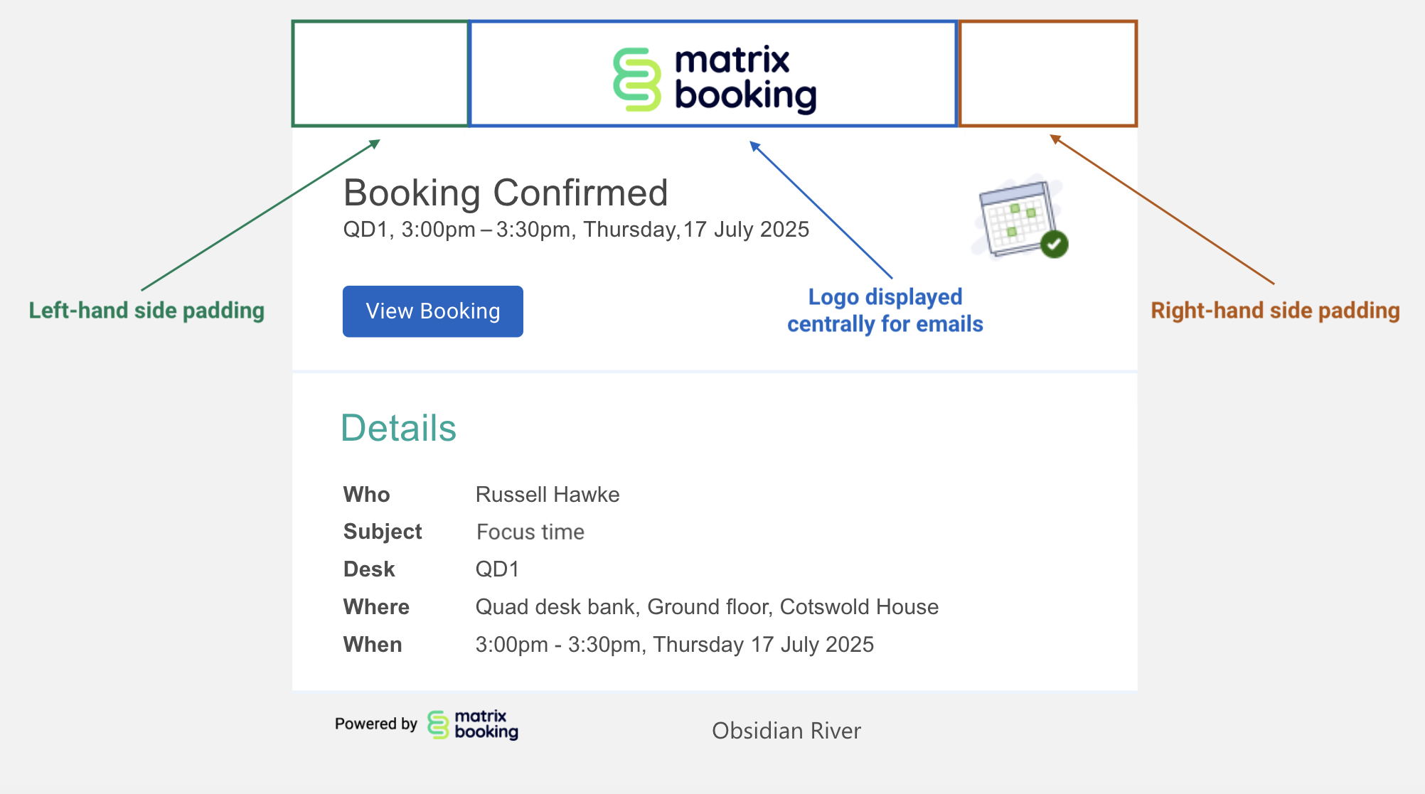

# Help Text

Please add the Help Text here that you want displayed on your organisations Help page – This text can be edited at any time by a Full Administrator:

**Example 1:**

If you are having any issues with Matrix Booking then please contact one of our local administrators:

<insert email address of administrator 1>

<insert email address of administrator 2 etc>

**Example 2:**

If you are having any issues with Matrix Booking, then please raise a support ticket using the normal process <insert link to your own internal support portal / tool / ticketing system / support email address>

|  |  |
| --- | --- |
| **Workshop completed:** | xx xxx 2025 |