Matrix Booking

Tenant

Business Rules Workshop

V3 - July 2025

Contents

Ground Rules 3

Share details 3

User Roles 3

Specific Configuration Options for Matrix Booking – if setting up a new organisation 4

Visitor Management – if included 5

Logo requirements: 5

Instructions for Web application Logo & Floorplan/Sense Kiosk logo 5

Instructions for Email Logo 5

Help Text 6

Banner Text 7

Matrix Booking is easy to implement and run, however there are several areas that you should consider ensuring your migration to Matrix Booking is successful and stress free.

In this document you will find the key areas that you will need to consider. Some of these areas will need further investigation and work, however in the first instance this document can act as a checklist to follow when planning your Matrix Booking installation and will provide us with all the details needed to complete your system set up. (These settings can of course be amended at any time including after you have gone live)

# Ground Rules

1. These are the rules we agree in advance to ‘ready’ the system for go live. Once handed over to your onsite administrators, these rules are yours to own, and amend as you see fit.
2. It is important to correctly capture all the relevant information about your organisation. The system set up is based on the information you have given us in the completed templates. In each section we run through the various configuration settings (based on business rules) needed

**Please provide the NAME of your organisation (if it doesn’t already exist on Matrix Booking) and the way you wish it to appear in Matrix Booking?**

# Share details

**What building do you need us to set up access to?**

|  |
| --- |
|  |

# User Roles

Please refer to the Administrators guide (ACCESS ROLES SECTION) if you need a reminder of the different roles available: [Matrix Booking Administrator Guide](https://docs.matrixbooking.com/kb/ag-homepage)

|  |  |
| --- | --- |
| **Q.** | Please provide the names and email addresses for those who will be FULL ADMINISTRATORS of the whole system.  *Please note that these administrators will be responsible for maintaining your* ***OWN*** *organisation and Users (including access via security groups)* |
| **A.** | Please enter names and email addresses here |

User Management

|  |  |
| --- | --- |
| If you are using Active Directory Synchronisation then all of your staff / users will appear immediately in Matrix Booking. If you use SSO then the users / staff will only appear in the system once they have logged in for the first time. Therefore if you are NOT using Active Directory synchronisation then there are a number of ways you can have your users appear in the directory:   1. We can provide you with a template to allow you to upload a list of your staff - <https://bit.ly/MBL-User-upload> 2. You can send the completed template to us and we will upload this for you 3. We can enable ‘self registration’ so that your users are able to be automatically added when they register (not applicable if using SSO or if your domain name is spread across multiple organisations) 4. Manually invite your staff using the INVITE menu in Matrix Booking | |
| Q. | Which of the above options would you like to use to add users / staff to your system? |
| A. | 1, 2, 3, 4 or N/A as using Active Directory synchronisation (please delete as applicable) |
| Q. | As part of your Tenant Set Up – we will create a share to allow your users to have access to book at another organisation – this share will be protected by the use of a Security Group (you may have multiple shares set up in your organisation with different user lists associated to each individual share) – This user list can be populated internally by a full Administrator (Post training) or a user list can be provide to us and we can populate this for you - <https://bit.ly/MBL-User-upload> |
| A. | Please enter your preferred option here |

# Specific Configuration Options for Matrix Booking – **if setting up a new organisation**

|  |  |  |  |  |
| --- | --- | --- | --- | --- |
|  | **Configuration Option for a new organisation (please ignore if not)** | | **Answer** | |
| 1. | When you go into ‘All Bookings’, what is the default number of entries per page (before pagination – default is 10)? | XXX | |
| 2. | When you click 'My Bookings' on the web do you want the user to see just the bookings they have made or also ones where they are an invitee? | OWN / ALL | |
| 3. | By default, we request the content of your Help section (see below), If you prefer, we can set up a single email address to receive help emails. | 1. Customised help text  2. Email address= [xxxx@xxxx.com](mailto:xxxx@xxxx.com) | |
| 4. | Logo required on Website? Who will provide? (See details below) |  | |
| 5. | Logo required in emails? Who will provide? (See details below) |  | |

These are most of the decisions required around set up. They can be amended during the implementation and even after go live, but it is useful to have the discussions internally around some of these so that everyone is clear and have ‘bought in’ to any new ways of working or meeting behaviours.

# Visitor Management – if included

|  |  |
| --- | --- |
| **For visitor** **management to work effectively there needs to be a reception defined – We will define a reception for each share as part of your implementation if applicable.** | |
| Visitor details are stored indefinitely unless otherwise specified. If required, please advise how many days visitor details should be kept for? | KEEP / Delete after **x** days |

# Logo requirements:

Matrix Booking allows you to add your own company logo to the web application, our kiosk applications and also the emails that are generated from Matrix Booking. If you wish to do this then you will need different logo’s (styles) for each part. The information below outlines what you need to provide us so that we can upload these for you.

We will normally do this as part of your set up / implementation if requested however they can be added, removed or updated at any point after go live simply by providing us the file(s) or links and then **raising a support ticket with the details.**

## Instructions for Web application Logo & Floorplan/Sense Kiosk logo

1. The logo either needs to be supplied to us or a URL provided where we can link to it
2. The logo needs to be transparent (therefore a PNG or GIF file)
3. It needs to be in landscape orientation and ideally 'letterbox' type aspect ratio
4. No more than 400 pixels high
5. For the floorplan kiosk logo all the above rules apply however a LIGHT variant of your logo should be provided as the backgrounds it is displayed on are much darker

## Instructions for Email Logo

1. The logo either needs to be supplied to us or a URL provided where we can link to it
2. The logo should NOT be transparent (can be PNG, JPG, GIF)
3. Dimensions should be 640 pixels x 152 pixels
4. The logo will by default have a white background (so white to the left and right of it. If the logo has any kind of background colour then please specify any colour padding required six digit hex color values preceded with # (below is an image showing how the colour padding works)

Example of an email with a Logo and right and left padding:

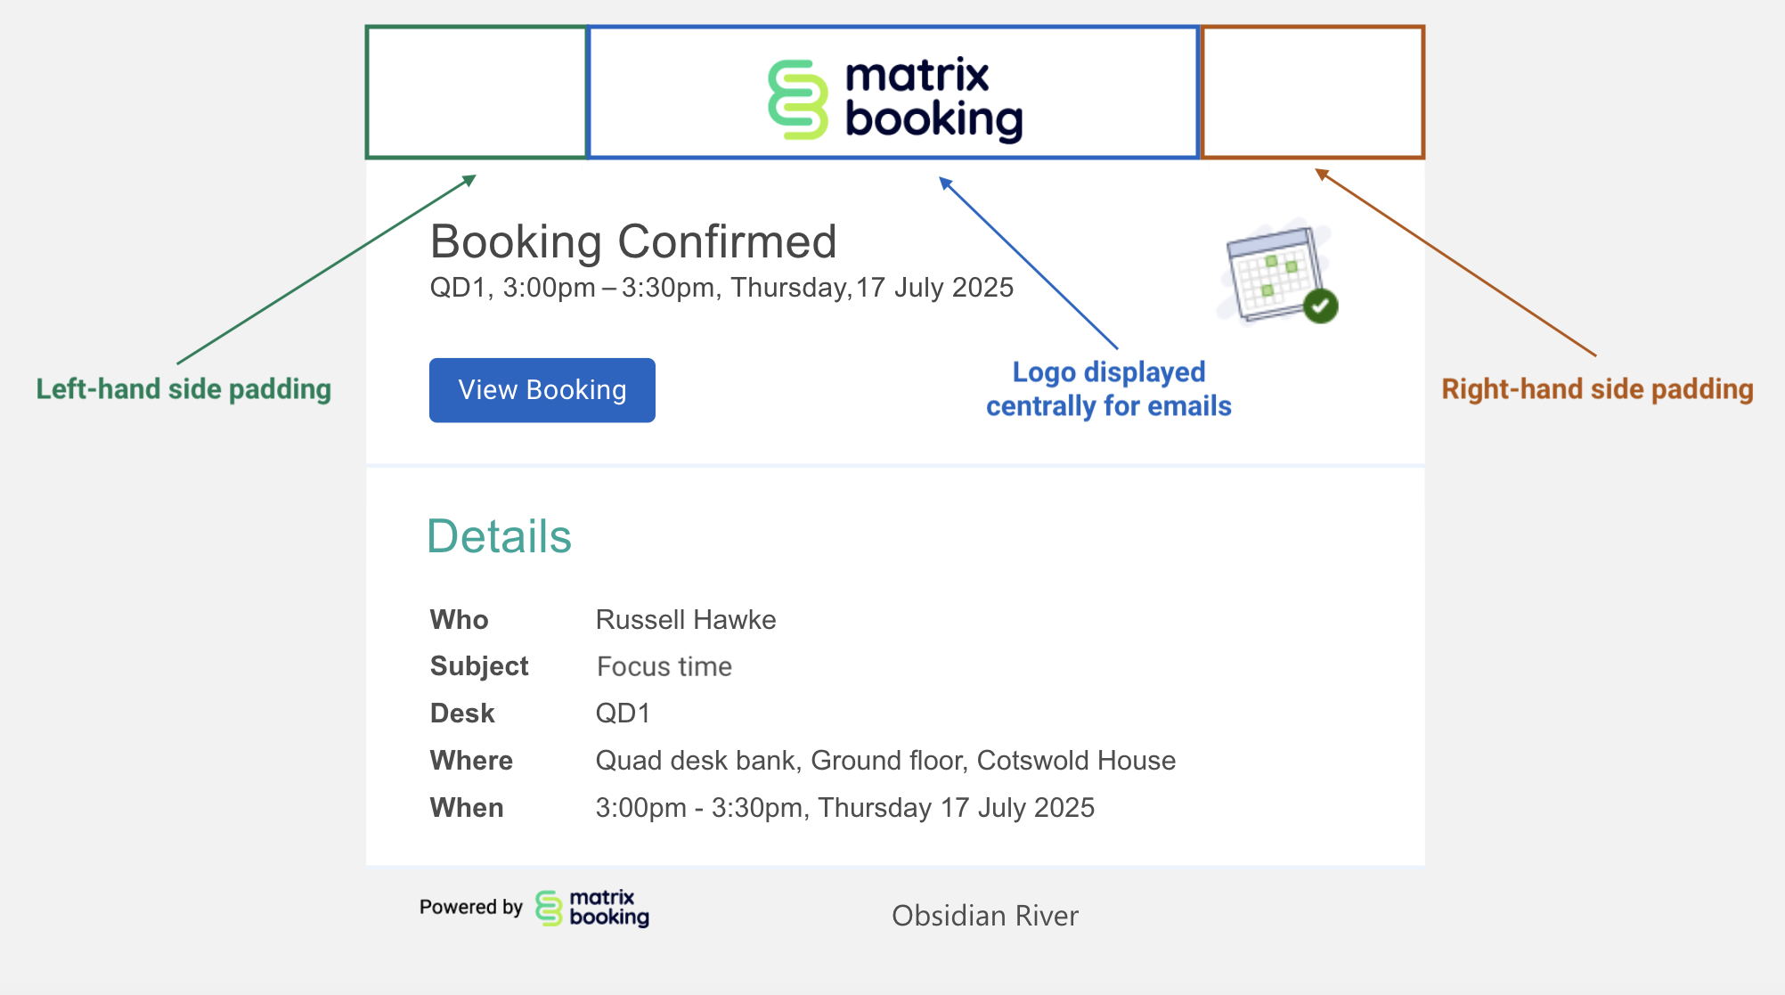

# Help Text

We strongly recommend that you use custom help text, so if you are wanting to have your own specific text on a help page then please enter the text below. You can amend this yourself at any time:

As a tenant, you users may be added to your system in various ways, but in order to have access to a shared location, they need to be added to the relevant security group. If they are unable to access certain areas, the help text should explain who to contact.

**Example 1:**

If you are having any issues with Matrix Booking then please contact one of your local administrators:

<insert email address of administrator 1>

<insert email address of administrator 2 etc>

**Example 2:**

If you are having any issues with Matrix Booking, then please raise a support ticket using the normal process <insert link to your own internal support portal / tool / ticketing system / support email address>

**Example 3:**

Booking Data feeds utilisation reporting, therefore check in compliance is mandatory to ensure the best possible data.

**Technical Problems** – Please contact the Service Desk – [ServiceDesk@yourorg.co.uk](mailto:ServiceDesk@yourorg.co.uk) for the following issues:

-Missing KIT on desks

-No network connectivity

-Issues Accessing Matrix Booking

-If you can access Matrix Booking but do **NOT** have access to book in certain locations, then contact us and ask to be added to the relevant user groups that control access

-**Operational queries** – Please contact the Local Business Support team for the following issues:

- Cancelling desk/rooms

# Banner Text

As part of the 'return to work’ series of changes we have created the ability for an organisation to have their own 'banner' announcement at the top of the page.

**Once enabled, you have two options:**

1. Simple announcement
2. Announcement with a click through to a new page of content that you can edit and manage yourself.

**An example of these is are displayed for you below with some dummy text around visitors to give you an idea of how they will look.**

**Simple announcement**

**Announcement with click through**

**Showing the click through page itself**

If you require the operations team to create a banner on your behalf, please fill out the below for content (This is also covered in your Admin training and can be added/updated by an internal administrator)

**Title:**

Enter Text here

**Subtitle:**

Enter Text here

**Additional Information:**

Enter Text here

|  |  |
| --- | --- |
| **Workshop completed:** | xx xxx 2025 |